Clerk’s Office Use Only Rec’d Date By:
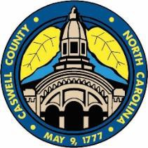

Caswell County Volunteer Application for Boards and Committees
This application is a public document

If you work or live in Caswell County, at least 18 yrs old, and willing to volunteer your time and expertise to your community, you may apply to serve on an advisory board by completing this form online or download it and mail to:

Caswell County Administration Email: csmith@caswellcountync.gov Attn: Carla Smith
P.O. Box 98
144 Court Square
Yanceyville, NC 27379

Name:

Home Address:

City: Zip Code:

Phone: Email:

Place of Employment:

Please list any County Boards you currently serve on:

Please list the Boards/ Commissions on which you wish to serve. Please indicate your preference by prioritizing your selection:
first choice being “A” and so on.

A.
B.
C.

Why do you wish to serve on these boards?

Please describe background, education, and abilities that qualify you for these boards:

Do you have any personal or business interest that could create a conflict of interest (either real or perceived) if you are appointed to this board? Yes No If yes please explain:

Which Board of Commissioners district do you live in? You can use the map on below to identify your district.

District 1
District 2
District 3
District 4
District 5
Not Sure
NA

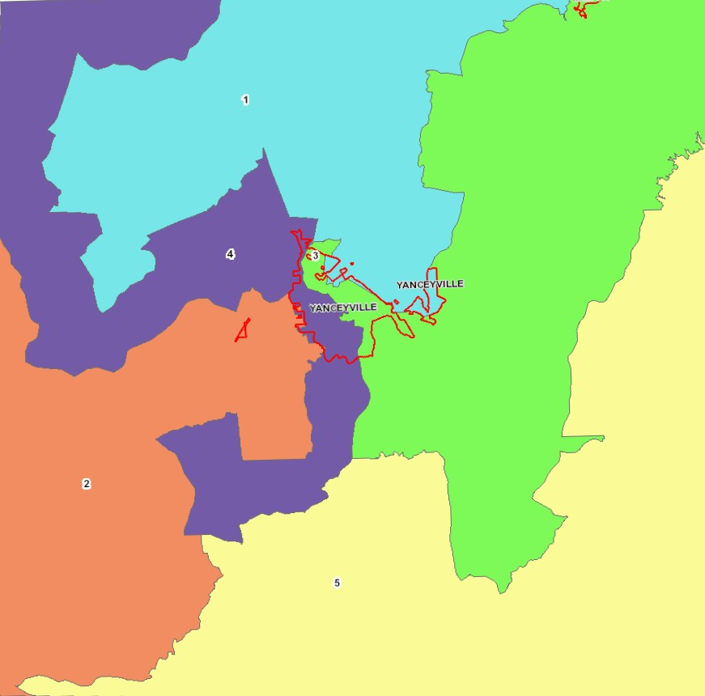

Demographic Information (Optional)
We ask your help in assuring diversity of membership by answering the following questions: Male Female
Age Range: 18-34 35-59 60+

Ethnic background:

Asian
Black/African American
Hispanic
Native American
White
Other

How did you become aware of these volunteer opportunities? Check all that apply
County Web Page Newspaper Radio Current Volunteer Other

