Clerk’s Office Use Only
Rec’d Date __________
By: ________________
Caswell County Volunteer Application for Boards and Committees
This application is a public document

If you work or live in Caswell County, at least 18 yrs old, and willing to volunteer your time and expertise to your community, you may apply to serve on an advisory board by completing this form online or download it and mail to:

Caswell County Administration Email: csmith@caswellcountync.gov
Attn: Carla Smith
P.O. Box 98
144 Court Square
Yanceyville, NC 27379

Name: _____________________________________________________________________________________________________

Home Address: ______________________________________________________________________________________________

City: __________________________________________________________ Zip Code: ____________________________________

Phone: ________________________________ Email: ______________________________________________________________

Place of Employment: ________________________________________________________________________________________

Please list any County Boards you currently serve on: ______________________________________________________________

_________________________________________________________________________________________________________

Please list the Boards/ Commissions on which you wish to serve. Please indicate your preference by prioritizing your selection:
first choice being “A” and so on.

A.______________________________ B.______________________________ C. ______________________________

Why do you wish to serve on these boards?

__________________________________________________________________________________________________________

__________________________________________________________________________________________________________

__________________________________________________________________________________________________________
Please describe background, education, and abilities that qualify you for these boards:

__________________________________________________________________________________________________________

__________________________________________________________________________________________________________

__________________________________________________________________________________________________________

Do you have any personal or business interest that could create a conflict of interest (either real or perceived) if you are appointed to this board? Yes ____ No____ If yes please explain:
____________________________________________________________________________________________________________

____________________________________________________________________________________________________________

____________________________________________________________________________________________________________

Which Board of Commissioners district do you live in? You can use the map on below to identify your district.

District 1 ___ District 2 ___ District 3 ___ District 4 ___ District 5 ___ Not Sure ___ NA ___

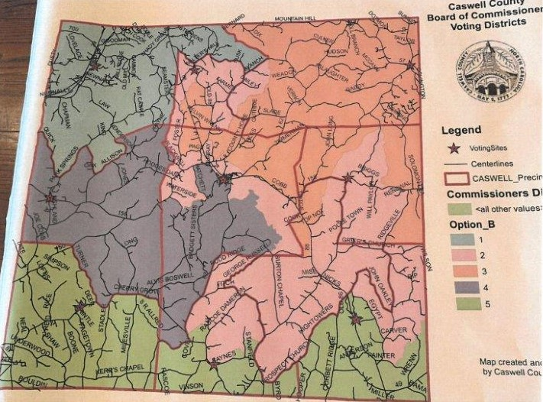

Demographic Information (Optional)
We ask your help in assuring diversity of membership by answering the following questions:

Male ___ Female ___

Age Range: 18-34 ___ 35-59 ___ 60+ ___

Ethnic background:
Asian ___ Black/African American ___ Hispanic ___ Native American ___ White ___ Other ___

How did you become aware of these volunteer opportunities? Check all that apply
County Web Page ____ Newspaper ____ Radio ____ Current Volunteer ____ Other ____

