MINUTES – SEPTEMBER 4, 2018

The Caswell County Board of Commissioners met in regular session at the Caswell County Historic Courthouse in Yanceyville, North Carolina at 9:00 a.m. on Monday, September 4, 2018. Members present: Nathaniel Hall, Chairman, Rick McVey, Vice-Chairman, Sterling Carter, Jeremiah Jefferies, David Owen and Kenneth D. Travis. Absent: William E. Carter. Also present: Bryan Miller, County Manager, Brian Ferrell, County Attorney and Luke Burris representing The Caswell Messenger. Paula P. Seamster, Clerk to the Board, recorded the minutes.

MOMENT OF SILENCE

Chairman Hall opened the meeting with a moment of Silent Prayer.

PLEDGE OF ALLEGIANCE

The Board of Commissioners and all the guests in the audience recited the Pledge of Allegiance.

APPROVAL OF AGENDA

Chairman Hall stated that he would like to amend the agenda to delete Closed Session.

Commissioner Travis moved, seconded by Commissioner McVey to approve the agenda as amended. The motion carried unanimously.

APPROVAL OF CONSENT AGENDA

Commissioner Travis moved, seconded by Commissioner Owen to approve the Consent Agenda. The motion carried unanimously.

The following item was included on the Consent Agenda:

A. Approval of Minutes of August 20, 2018 Regular Meeting

(At 9:02 a.m. Commissioner S. Carter entered the meeting.)

PUBLIC COMMENTS

Chairman Hall opened the floor to Public Comments.

Chairman Hall asked if there was anyone that would like to speak during Public Comments. With no comments Public Comments was closed.

RECOGNITIONS

Commissioner McVey stated that he would like to recognize all the Fire Departments that were involved in the training course to try to get the homeowners’ insurance rates down. He added that the training went well and that everyone did a fine job and he was proud to be a part of it.

Commissioner S. Carter stated “I would just like to add my remarks as well in addition to Commissioner McVey, that was a great day that we were there to enjoy. All of our fire fighters were doing an exceptional job and the state even commented that we were making history; we were setting the example for other counties, I was glad to hear that. And as well on that day we had the Back to School Drive at the Parks and Rec., that was a fantastic event and everyone involved in that I would just like to extend our thanks to them in helping our students. And the Colby Richmond Ride, Memorial Ride, had a great turnout as well. It was nice to see some happenings in Yanceyville that day and would just like to thank everyone involved.”

Mr. Miller added to what Commissioner McVey and Commissioner S. Carter said, there was a tremendous support at the Back to School Bash which was a huge success. He added that there were hundreds of people there throughout the entire event. Mr. Miller thanked the organizers of the event but he also recognized Brandon Enoch, Johnny Crumpton and Angela Wilson from Parks and Rec. for their efforts in setting up for the program. He added that on the ISO ratings field test for the fire departments went very well and that even though the fire departments were going up against paid departments the county departments set several state records as far as times and he wanted to commend them for their efforts.

Chairman Hall recognized the Farmer Lake Board and Staff at Farmer Lake. He was involved with a kayaking/canoeing event this past weekend. The support was great and the lake looked immaculate. Chairman Hall added that many Caswell citizens are not going to Farmer Lake and those that were there for the first time were greatly surprised at what the County has to offer there.

OPPORTUNITY ZONES

Mr. Joseph Furstenberg, Economic Development Planner, with the Piedmont Triad Regional Council gave the following slide presentation to the Board:

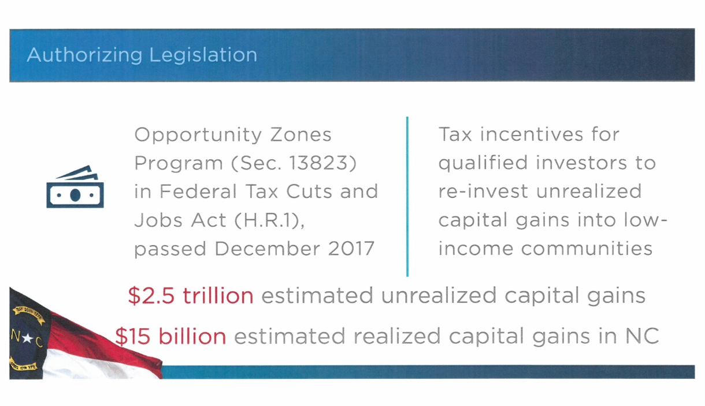
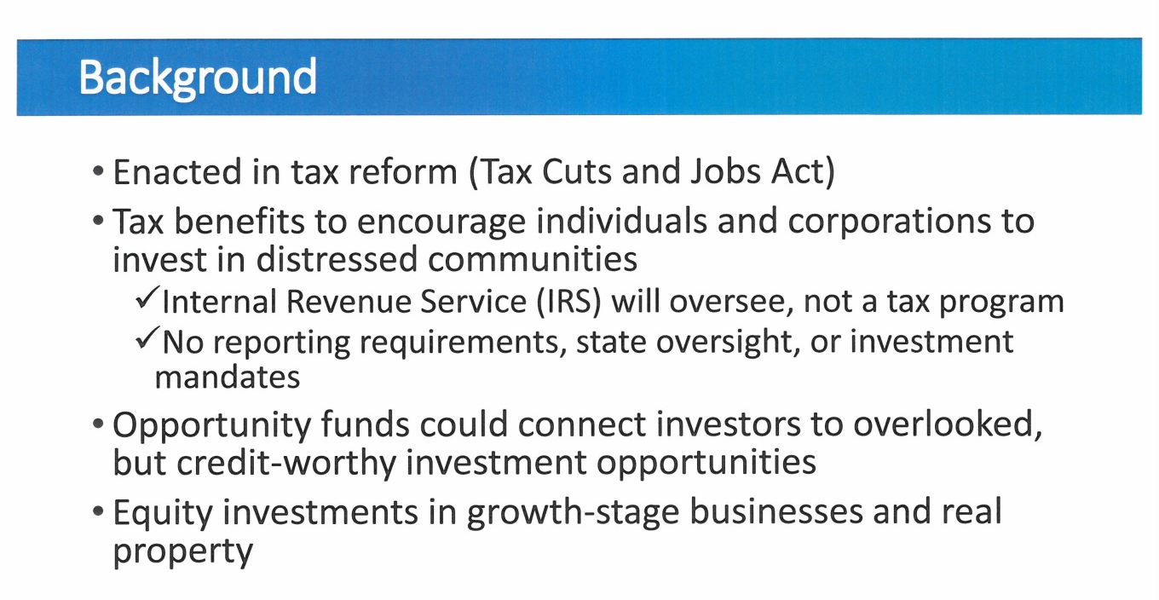

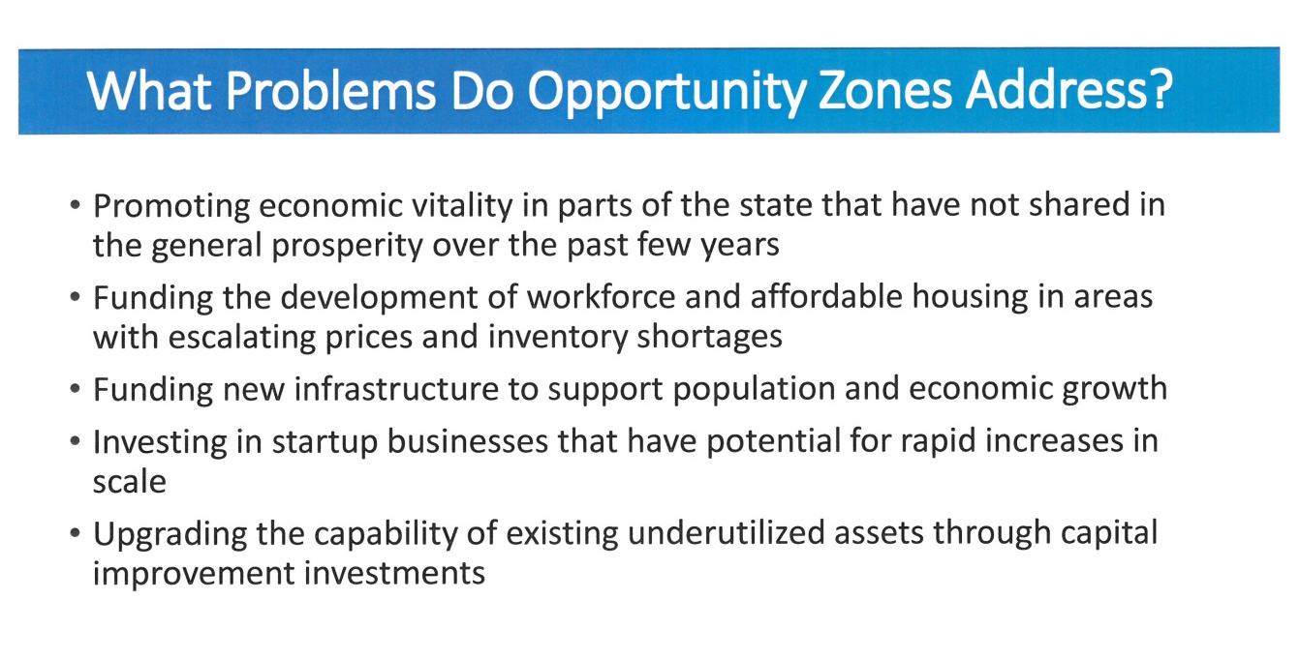
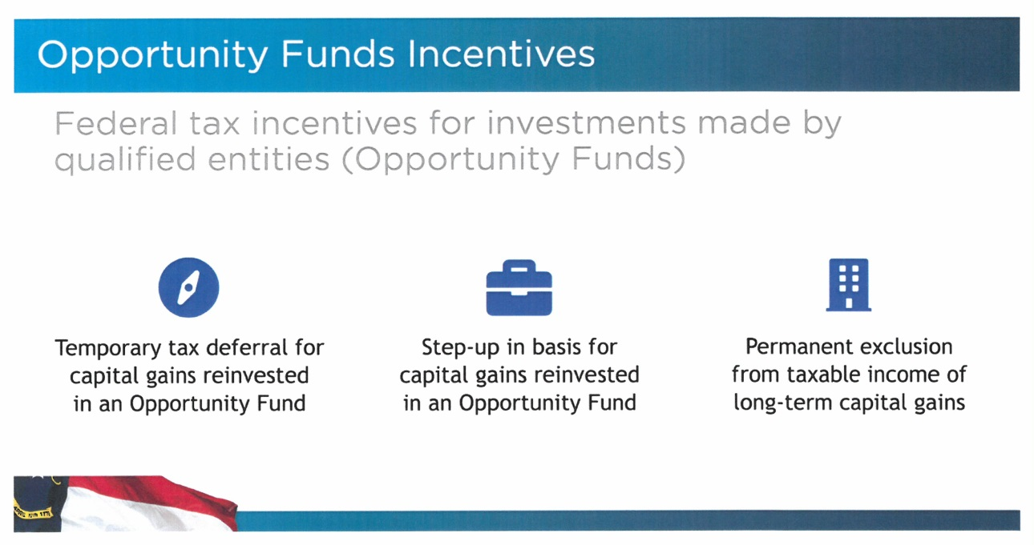

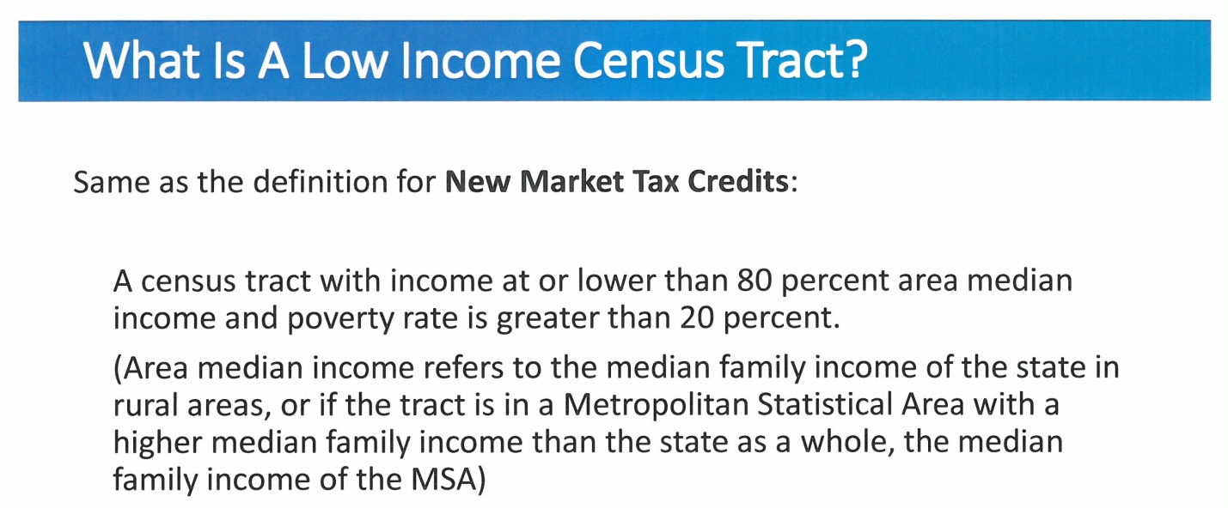
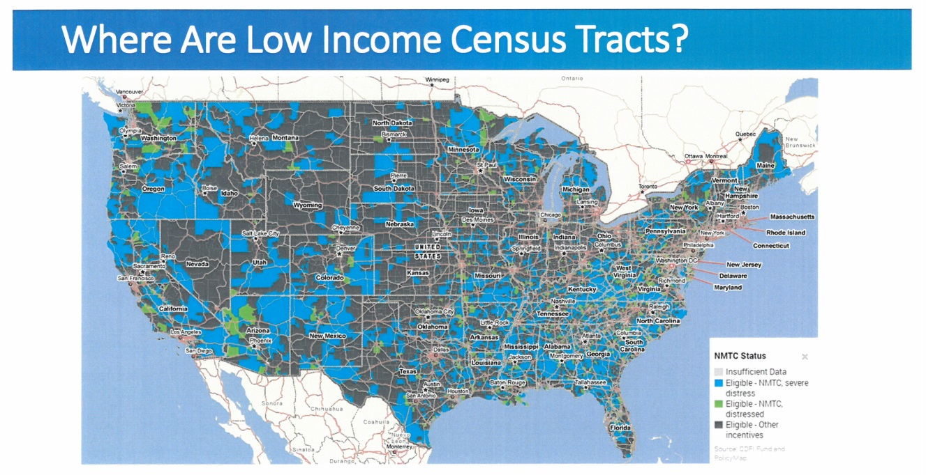

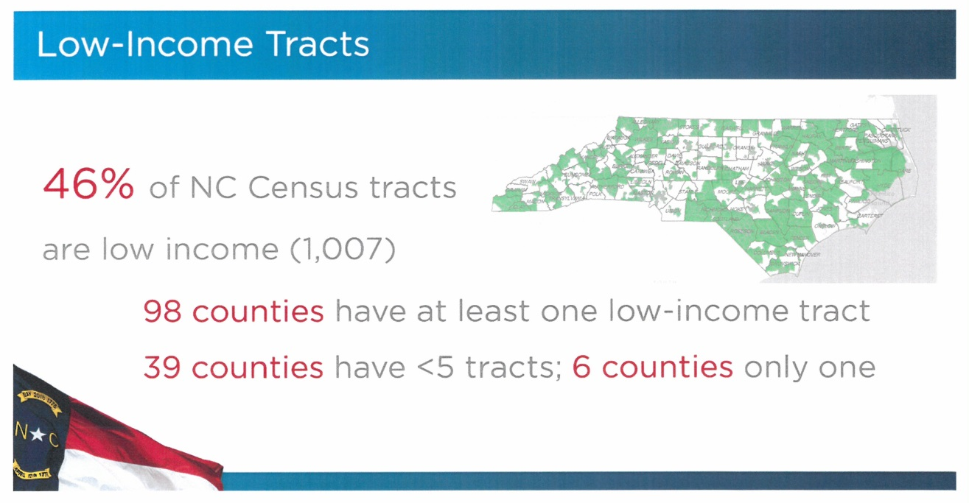
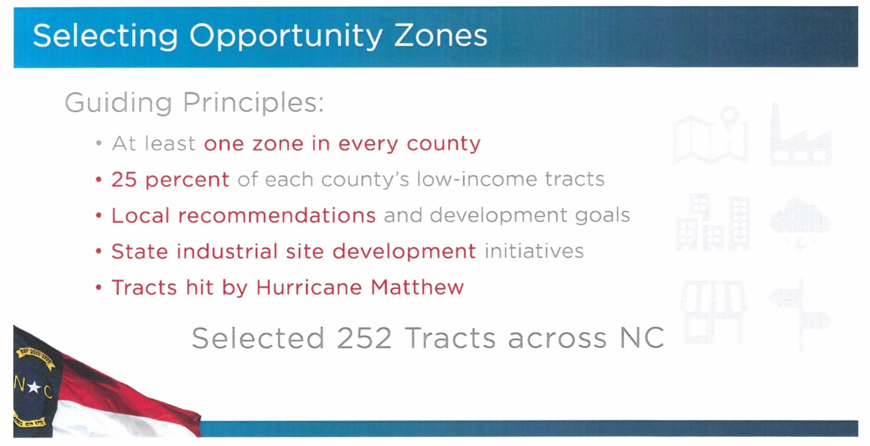

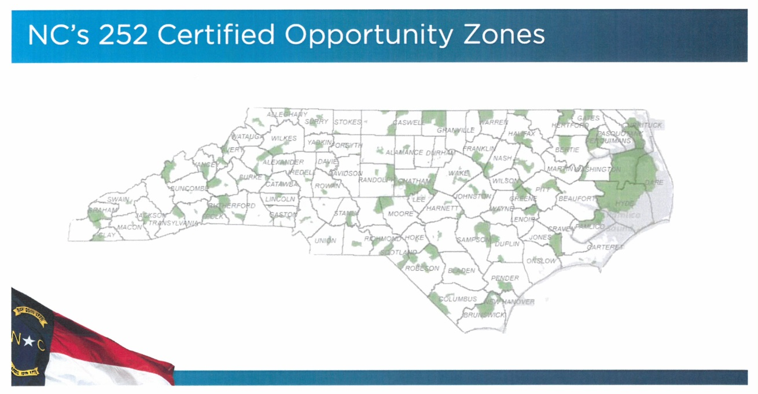
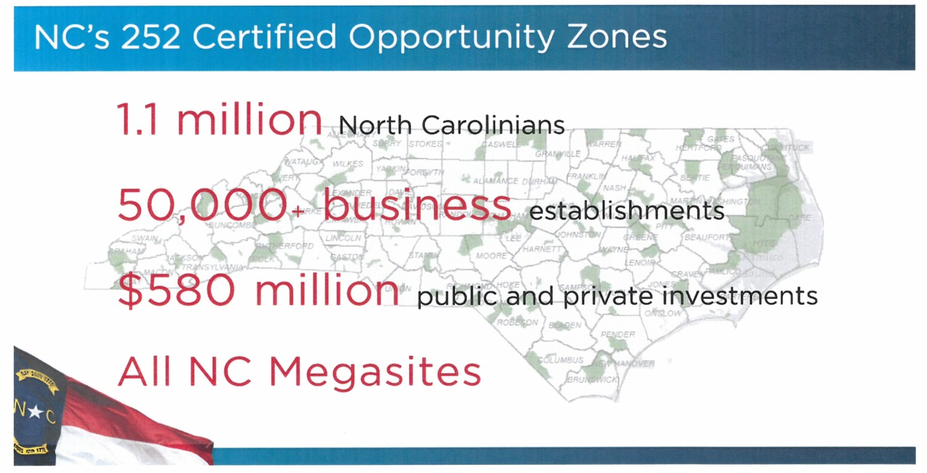

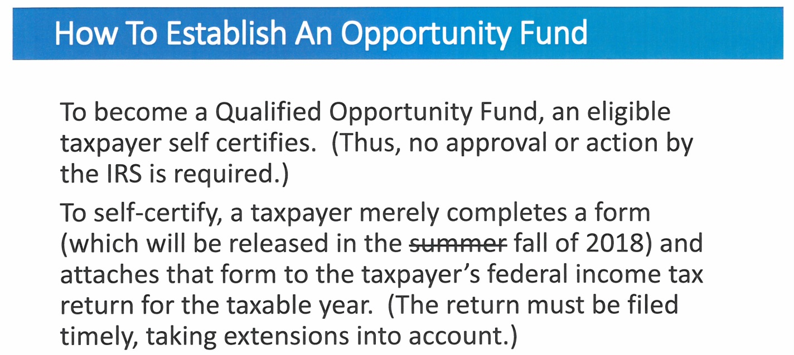

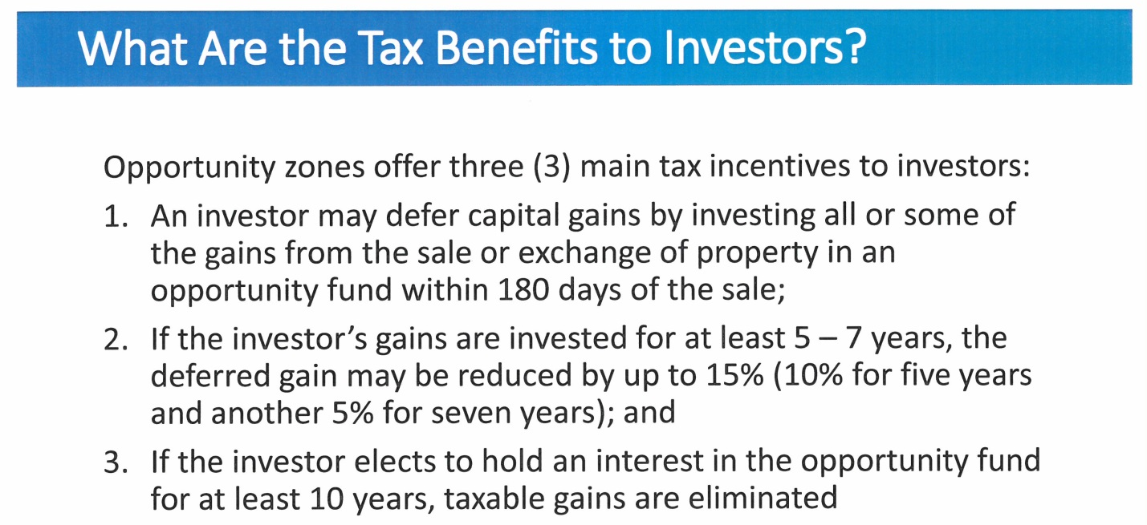

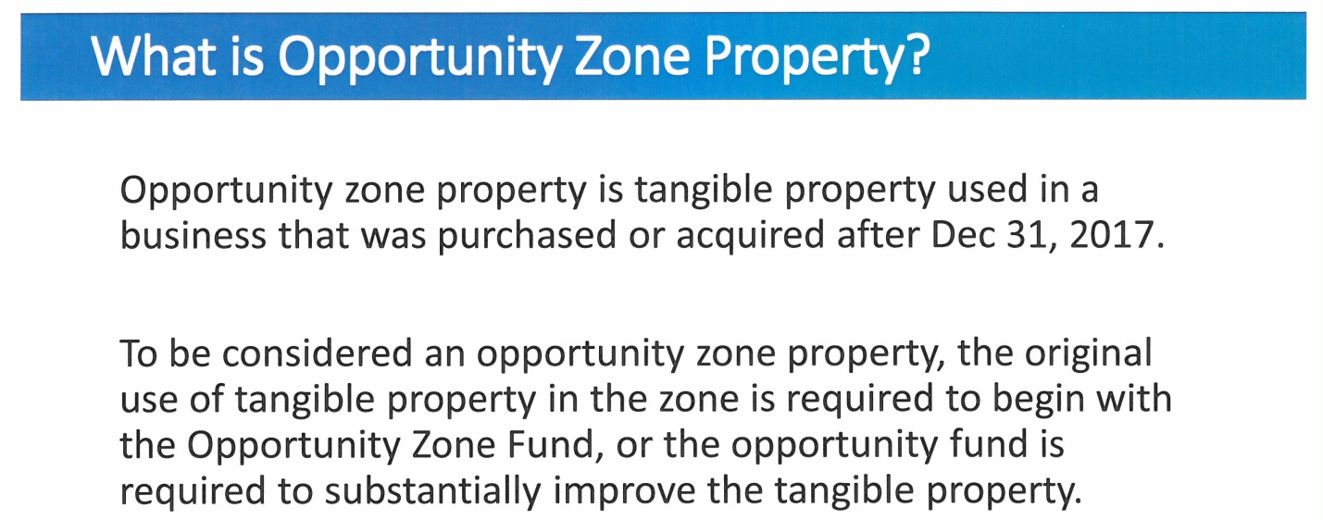

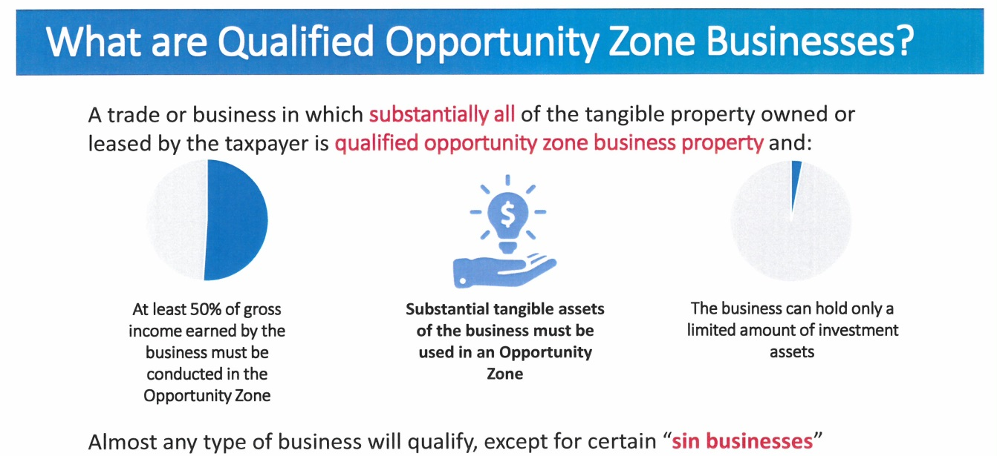

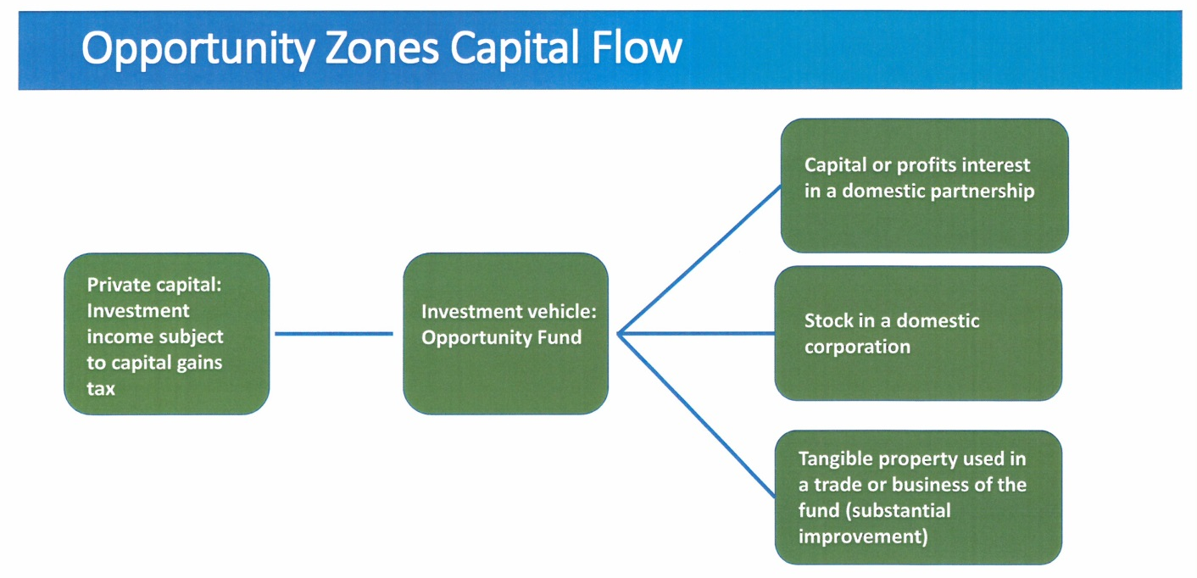

Chairman Hall stated that this only recognized a small portion of the county so he wanted to know what happened to the rest of the county and why didn’t more areas qualify as an opportunity zone. Mr. Furstenberg responded that it is the new market, tax credit qualification. He added that there was one in Yanceyville but it did not make it through the process with the State and the Governor made the final decision.

Commissioner S. Carter stated “Just curious with our census tract there I saw that the qualification of 50% or more of that business has to be within that location so I am somewhat concerned with us being a border county and also being right there close to Rockingham County as well that we may be at a great disadvantage with this so I don’t know if you can pass that along. Yeah there are going to be other counties similar to us that are going to be in those vital intersections of multiple places so I feel like that may affect us negatively to a certain degree but it sounds like a great program and I appreciate you presenting it.”

Mr. Miller asked Mr. Furstenberg to go over the types of projects that could qualify for this type of funding. Mr. Furstenberg responded that it is going to be pretty much wide open. He added that there is a group out of Washington that is a non-profit that has been guiding this and putting on webinars on these opportunity zones. Mr. Furstenberg stated that projects included in this funding would be industrial development, business expansions and business startups. Mr. Miller asked if it has been determined as far as an average size of a project. Mr. Furstenberg responded that this is hard to say since the fund is not set up yet.

Chairman Hall asked Cori Lindsay, Caswell County Economic Developer, if she had had any discussions or contacts with the governor’s office or other contacts on how Caswell County can expand its area on the map. Ms. Lindsay responded that it is her understanding that the map will not change because it has been approved by the federal government and the opportunity zones are set for this program. She added that there may be another program at another time.

Mr. Miller asked if there was anything Caswell could do to attract investors. Mr. Furstenberg responded yes Caswell could work with investors and set up its own fund for this type of project.

AGRICULTURAL ECONOMIC DEVELOPMENT

Mr. Miller presented the following slide presentation to the Board on Agricultural Economic Development:
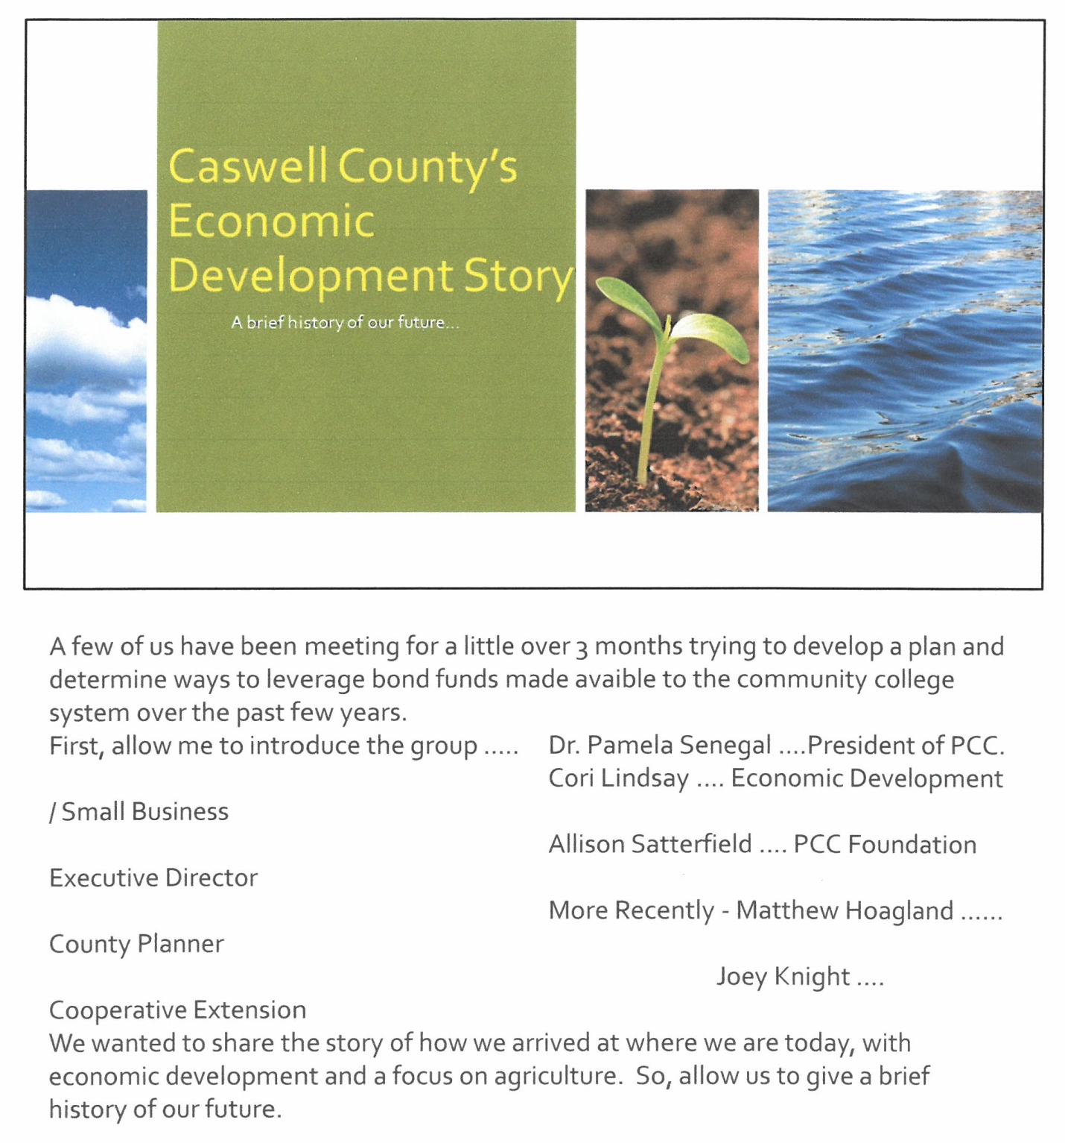

Commissioner Owen stated that he had the opportunity to see this beforehand but he wanted the Board to understand that when it is said about matching money the county’s part is the land at the Pelham Industrial Park. Mr. Miller responded that this was correct and that no money from fund balance for this type of project. He added that he would be glad to meet with the members of the Board on a one on one basis and answer any questions they may have.

Chairman Hall asked if the manager had any idea of a kick off date on the project. Mr. Miller responded that there is a lot that has to be accomplished to leverage the funds. He added that he thought PCC would engage in a private donation campaign led by Ms. Allison Satterfield. Mr. Miller stated that there are strategic items that have to be worked out before the project can begin. He added that the 2020 deadline for the expenditure of the funds is quickly approaching so this will have to be worked through very quickly and will be back in front of the Board in the near future.

DISCUSSION OF COLLABORATION WITH LOCAL ARTS COUNCIL

Commissioner Owen stated the he hoped the Board had an opportunity to review the information he had gave them at the last meeting regarding artwork on the public utility boxes. He added that the backflow covers in front of the courthouse stand out like sore thumbs and there are several others throughout down so he started to think about how they could blend in better in the surroundings. Commissioner Owen stated that he had a conference with the Local Arts Council Director about the possibility of using local artist that would paint a film that would be applied to the covers or paint the covers themselves to dress up the area which will give the local artist the opportunity to display their work. He added that director was very enthusiastic about this and believed that she could get enough grant money to cover any and all expenses of it. He added that he did inform the director that the county did not have any money to contribute to this project but he did hope that the local artists would paint and display local history and culture on the covers. Commissioner Owen has for the thoughts of the Board and if the Board would approve this collaboration with the Local Arts Council with the agreement that nothing would be put on the boxes without the prior approval of the Board.

Commissioner Jefferies stated that he did not have a problem with this. Commissioner S. Carter stated “Great idea.” Commissioner Travis stated that it was fine with him.

Chairman Hall stated that with the consensus of the Board he asked Commissioner Owen to proceed and that he hoped that a committee would be formed and make reports back to the Board periodically. He added that it is a great idea.

RECESS

The Board took a brief recess.

DISCUSSION OF CLOSED SESSION AGENDAS AND PROCEDURES

Commissioner Owen stated that he has had some person concerns over the last several months when the Board has met in closed session without the attorney present or at times staff and he felt the discussion was kind of pushing the envelope on what the Board should be discussing in a closed session and for transparency to the citizens he felt he should bring this up during open session. He asked the Board for its feelings on this as well as a consensus on how to handle closed session when the attorney is not present.

Commissioner S. Carter stated “Mr. Chairman, I completely agree with those remarks. I’ve, you know, since I’ve been on the Board there has probably been several instances and Mr. McVey would probably agree with me on this where we’ve kind of reached that uncomfortable threshold and we’re you know absent of an attorney and we are unsure, it is not our training to know all of those rules but I would definitely hope that in the future we could have access to our attorney whether he’s in the building or whatever before we dismiss him completely in whatever instances those may be.”

Commissioner Owen suggested that the Board look at the Rules and Procedures for the Board and incorporated something in there that if the county attorney is not going to be present that the item is approved beforehand so the attorney can kind of guide the discussion. Commissioner Travis responded that there have been times that the Board has dismissed him so he is not in the meetings. Commissioner Owen continued by saying that some of the items that were discussed no one knew about them until closed session or at least he was not aware.

Chairman Hall stated that procedurally how the Board proceeds is up to the Board collectively. He asked the county attorney is there was a requirement for him to be in closed session. Mr. Ferrell responded that the only time he is required to be in closed session is when the Board is discussing Attorney/Client privilege because he would need to be present to give the legal advice. Chairman Hall continued by saying that each Board member gets the required training on what to do, what not to do, what to say and what not to say in closed sessions and once this training has been taken the Board member can governor himself or stop another commissioner who is not following the proper procedures. He added that by December the Board needs to be prepared to do this training.

DISCUSSION ON LEGISLATIVE GOALS

Chairman Hall stated that every 2 years the counties put together a list of legislative goals to send to the North Carolina Association of County Commissioners to lobby for the citizens of North Carolina and this process has begun. He added that he has received some items from Commissioner Owen that needs to be discussed. Chairman Hall stated that this will be an item on the next agenda and he suggested that the Board submit its legislative goals to the clerk. He also recommended that the Board attends the Legislative Conference in January.

DISCUSSION ON FLEET MANAGEMENT

Chairman Hall stated that this was not necessarily a discussion but he wanted to bring something to the Board’s attention. He added that there was a policy on fleet management presented to the Board several meeting back but the Board did not feel comfortable with the policy so no action was taken. Chairman Hall stated that in the last 3 or 4 weeks the county had an employee that was going out of town for a conference and this employee was on the interstate when the county vehicle started acting strange. He added that this employee called the clerk which in turn called Commissioner Travis and Commissioner Travis informed her to get the vehicle off the road. Chairman Hall stated that it was learned later that the vehicle had 4 dry rotted tires and the county put its staff at risk because no one is inspecting the county’s vehicles on a routine basis. He added that the reason he is bringing this issue up is because the Board needs to discuss how to handle the county’s fleet and have someone in charge of this inspection.

Commissioner Travis stated that he would like to know when the vehicle was last serviced because the tires should have been checked. He added that when the clerk called him he told the clerk to have the employee to take the vehicle immediately to a tire place because it sounded like the tires were separating and that is what it was. Commissioner Travis asked the county manager to check to see who serviced that vehicle before it left town to get back to the Board on this information.

Commissioner McVey asked if the Board discussed hiring someone to handle the fleet management or to have the maintenance department to handle this. Chairman Hall responded that the Board discussed a lot of options but no action was taken.

Commissioner Jefferies asked Commissioner Travis if the tires are inspected during an inspection. Commissioner Travis responded that the depth of the tires is inspected. He added that an employee can look at the tires and they can look good but when you start driving that is when you notice a problem with the tires. Commissioner Travis stated that this is the county’s fact as well for not have a policy on what needs to be inspected on these cars when they are services.

Commissioner Owen agreed with Commissioner Travis that the county needs a check off sheet for the maintenance of the county vehicles and for the safety of the county employees. Mr. Miller responded that the last policy there was a schedule to follow for preventative maintenance for the employees as well as at the repair facilities. Commissioner Owen stated that the reason that policy was not approved was because it put the responsibility on the maintenance department and there are not enough maintenance personnel to handle this. Mr. Miller responded that the check list can be brought back before the Board at the next meeting.

Commissioner McVey asked if the county had a contract with a service facility. Mr. Miller responded no that the vehicles are taken to different service facilities. Commissioner McVey recommended that there be a contract for the service of the vehicles.

Commissioner Travis stated that most counties bid the service of the vehicles out to different shops that way if something happens the county knows who worked on that particular vehicle.

Commissioner S. Carter stated “I think first of all we should full responsibility of what happened with that vehicle, it troubles me that that incidence occurred. I agree with the comments that Commissioner McVey and Commissioner Travis said about having a contract where they all go to one place so you have that oversight to stay on top of these things. I still have the opinion that it needs to be an individual that manages this fleet, whether that is part time, full time, whatever it takes, I don’t think it should be on the county employees in the various departments to know about all of these things and to know what to do with the check list. I have no problem with what was presented to us; it’s just the requirement of who is responsible for that oversight. I feel like this is a common sense situation and we just need to handle it and I would ask if the Board agrees that we should have this on the next agenda item to go ahead and take care of something in regards to at least that policy of who should be handling maintenance on our vehicles. Speak now or forever hold your peace. Do you think we can talk about it at the next meeting? I mean that sounds like something… Chairman Hall responded that that was the reason why he put it on the agenda this time. Commissioner S. Carter continued “Of course.” Chairman Hall responded that the next meeting would be okay to talk about it.

Commissioner Jefferies liked the idea of putting this out for bids. Commissioner Travis stated that it is time for the Board to say how this will be handled instead of allowing the vehicles to go wherever and to have it put out for bids and award a contract.

Commissioner S. Carter asked “I was just going to ask the county manager, when we were writing up that policy was any of that checked into the preliminary as far as the bidding goes on one main service?” Mr. Miller responded that staff has looked into prices for regular services and this was entertained when the policy was being written.

Commissioner McVey asked if the ambulance were included in the fleet management policy. Mr. Miller responded no.

Chairman Hall stated that there is a way to incorporate everyone’s suggestion to ensure the county’s vehicles are maintained and safe for county employees. He added that this item would be on the next agenda unless there is an objection from the Board.

Commissioner S. Carter asked “Mr. Chairman, are we directing the county manager to start that process for the bidding before the next meeting so we have ballpark ideas?” Mr. Miller responded that without an approved check list he cannot start the bidding process. Chairman Hall responded that the bidding process cannot start but the county manager can break down the vehicles into various groups so the Board can understand how many different bids are needed.

Commissioner Travis stated that the Sheriff’s Department and ambulances need to be bided separate from the county vehicles. He added that oil changes cost different for the different types of vehicles.

Mr. Miller stated that he would have this information for the next meeting.

DISCUSSION ON DSS CHILD PROTECTIVE SERVICES

Chairman Hall stated that over the last couple of years he has personally received some concerns about the Child Protective Services at DSS. He added that this past week at the North Carolina Association of County Commissioners conference there was 2 presentations from the North Carolina Department of Health and Human Services (DHHS). Chairman Hall stated that the discussions that need to be held need to be between this Board and the DSS Board and Staff because the State has changed the role of the county commissioners. He added that the DHHS staff last week made it very clear that the Board of Commissioners are responsible for what happens in the Department of Social Services. Chairman Hall proposed that the Board have a meeting with the DSS Board and Staff to discuss the concerns that he has been receiving. He added that needs to be some policy and procedural changes discussed in this meeting as well and it may need to be in closed session. Chairman Hall stated that he had had a conversation with DSS staff but it was not an in depth conversation.

Commissioner Jefferies stated that he would like to address Chairman Hall’s concern about Child Protective Services because the DSS Board has rules that they have to follow and certain things cannot be discussed. He added that at the DSS meeting there is a public comments section and individuals are allowed to speak during this time to express their concerns because if DSS is not aware of what is going on they can’t do anything about it. Commissioner Jefferies stated that Chairman Hall could express his concerns with him or Commissioner Travis since they are both on the DSS board. Commissioner Travis responded that he did not think it was appropriate to talk about the concern at this point.

Chairman Hall stated that he understood what Commissioner Jefferies was saying and that he is absolutely correct that he did not give the board any details on his concerns and he did not think it was appropriate to talk about it now but it would be appropriate for the DSS board and the Board to talk about it. He added that as a commissioner he is not aware of all the rules of DSS. Chairman Hall stated that his biggest concern is how the state is going to hold the Board accountable for DSS. He suggested having a copy of the MOU that the Board signed to discuss this agreement and to have the county attorney present in the meeting as well.

Commissioner Jefferies asked Chairman Hall to withdraw his concerns. Chairman Hall responded that he would not withdraw his concerns but he will not talk about them because it has to do with confidentiality.

Commissioner Travis recommended having this meeting before a Commissioners meeting since the Board would like to have the county attorney present. Chairman Hall responded that everyone should check their schedules.

TRANSPORTATION OPTIONS FOR PCC

Mr. Miller stated that this was the second time that this information has been in front of the Board and not a lot has changed since the last meeting. He added that he did talk with Rodney Jackson, Caswell Campus Dean, and Mr. Jackson provided him with the degrees that were available at the Caswell Campus. He added that there is a list of classes that can only be taken in Roxboro such as Anatomy and Physiology. Mr. Miller stated that one of Chairman Halls’ questions from the last meeting was could a student get a degree from the Yanceyville campus and the answer is yes but it is for only a few degrees.

Chairman Hall asked if a student could get an Associate’s degree at the Caswell Campus. Mr. Miller responded no but student could get an Associate’s degree in Agribusiness, Digital Effects and Film, etc. Dr. Senegal responded that students could get a vast majority of the courses need to get an Associate’s degree in Caswell County but it is through a mix of face to face, ITV classes and online classes. She added that if the student prefers face to face classes having the transportation option would give the student better options for taking classes.

Commissioner S. Carter stated “So this will vastly enhance a traditional form of education.” Dr. Senegal agreed.

Mr. Miller stated that there would be 2 trips to the Roxboro Campus on Mondays and Wednesday which would cost $142.25 and 1 trip on Tuesdays and Thursdays which would cost $117.25. He added that CATS has an operational fund balance of $636,368 and is required to have an 8% fund balance. Mr. Miller stated that transportation is a barrier for a lot of students in the county. He asked Dr. Senegal if they kept a record of this information. Dr. Senegal responded that PCC did not keep this type of data. She added that students do tell them that transportation is an issue.

Commissioner S. Carter stated “The estimate for the $142 and the $117 is that a tradition, 2 semester full year or is this also including a summer session, that’s your annual estimate for transportation?” Mr. Miller responded that the $142 is for 2 trips for one day. Commissioner S. Carter continued “For one day?” Mr. Miller responded yes for one day. Commissioner S. Carter continued “Oh.” Mr. Miller responded that the actual yearly cost for the program is $20,358. Commissioner S. Carter stated “I guess I’m courage if we are charging this to the students, that is what I thought that was at first, that that would be an annual fee for them, sorry.” Mr. Miller responded that if the students were to be charged on a 15 person van basis it would be $464.50 per student per semester. Commissioner S. Carter continued “Thank you.”

Chairman Hall asked Dr. Senegal how many students from Caswell are attending classes for a degree at the Roxboro campus. Dr. Senegal did not have a number for that but she thought it would be several hundred. She added that this information could be tracked in the future to see what the impact is. Chairman Hall asked Dr. Senegal if fall registration had already started. Dr. Senegal responded that the fall semester has already started but they do have a series of late start classes available. Commissioner S. Carter stated “Mr. Chairman I was just going to make a comment to that, they have a great publication that is mailed to me every semester that has all the information and I would encourage other Board members to check it out. It can definitely give you a full picture of what is going on at both campuses.” Chairman Hall responded that he was aware of that and that he receives that publication.

Commissioner S. Carter asked “What’s our timeline as far as what is being presented to us and what we would like to do?” Mr. Miller responded that classes have already started this semester so if the program were to begin today the Board would not see the full potential but there would be some ridership. He added that he thinks it would take a semester or two to get the program established and for the students to know about the program.

Commissioner Owen stated that he thought it would be a good program but he would like to see some ownership from the students even if it is a nominal amount. He added that he is assuming that the money for this program is coming out of the CATS funding. Mr. Miller responded that this is correct. Commissioner McVey added that he was willing to try the program.

Commissioner S. Carter moved, seconded by Commissioner Jefferies to offer the transportation option to PCC students as recommended by the county manager.

Commissioner S. Carter stated “I would like to amend the motion I supposed we would be interested in starting this for the spring semester or immediately because as you said there would be some but we are late at this point. I was going to say spring, that we start this program in the spring.” Dr. Senegal responded that PCC has a waiting list now. Commissioner S. Carter continued “Oh you do, okay, awesome, okay now.”

Commissioner S. Carter moved, seconded by Commissioner Jefferies to approve the funding for the transportation program to come from CATS fund balance in the amount of $20,358 and that the program starts immediately.

Commissioner Owen asked if the motion could be amended to add a nominal charge to the students. Commissioner S. Carter responded “The number is $464 per semester.” Commissioner Owen continued by saying he was not looking for that dollar amount. Mr. Miller responded that this amount would be cost prohibitive to the students. Commissioner S. Carter responded “So are we suggesting maybe a certain percentage of that be covered by the students, 10% or...I don’t know what your thoughts are.” Commissioner Owen stated that there needs to be a student buy-in because this is tax money from somewhere. Mr. Miller responded that if the program is approved staff can bring back the cost estimates at the next meeting. Commissioner Owen stated that he was good with that as long as the Board is okay with some nominal charge.

Commissioner Travis stated that he would like to know how much the students are going to pay before it is voted on. Chairman Hall asked if he had an amount in mind. Commissioner Travis stated that it should be at least 10% or more. Commissioner S. Carter stated “I was thinking, you know, that is close to about $50 a semester that sounds reasonable.” Commissioner Travis stated that he could not see given the students a free ride.

Chairman Hall asked for a suggestion on a per ride or a daily amount. Commissioner Travis responded that the Board should have had some of these options before voting on it. Mr. Miller stated that any number presented to the Board would be cost prohibitive to the students so it is the Board’s decision on the charge, whether that is 10%, a daily pass of $2 or $3 or $5 but he added that the actual cost of the program would be cost prohibitive to the students.

Commissioner S. Carter asked “Mr. Chairman, I was going to ask Dr. Senegal how many days are in regular semesters total, do we know?” Dr. Senegal responded that it is about 100 days. Commissioner S. Carter continued “So a hundred days you don’t want to charge $5 a trip, that’s, that’s, you can see your number then but that is what I am trying to you know figure up in my head is…it would be a small fee per ride I would say.” Commissioner Travis responded that he thinks the county should charge 10% of what it would cost to ride that day. Commissioner S. Carter stated “Right, are you…do want per semester…I know we mentioned per ride also because some days you would not have an individual going to a class depending on what program they were in.” Mr. Miller responded that if the Board wanted to use the 10% amount the charge would be $50 for a semester pass or $2 for a daily ride pass and both of these can be implemented. Commissioner S. Carter continued “I think that’s a reasonable rate. I agree with the option of choosing either one.” Commissioner Owen responded that he would agree with this. Commissioner S. Carter asked “Would you like for me to amend the motion? Ms. Seamster do you have the main motion written down, so this would be amending that motion.”

Commissioner S. Carter moved, seconded by Commissioner Jefferies to approve the funding for the transportation program to come from CATS fund balance in the amount of $20,358 and that the program starts immediately and offering the students a $50 semester pass or $2.00 per day charge. The motion carried unanimously.

RECESS

The Board took a brief recess.

SHERIFF’S OFFICE REQUEST FOR ADDITIONAL POSITIONS

Mr. Miller stated that he had provided the Board with the revenue and expense data that had been requested at the last meeting for an additional Detention Center officer and for the SRO position.

Commissioner Jefferies stated that the county should end up with $70,000 to the good with this. Mr. Miller responded that actually since the SRO position is funded by grant funding and if the inmates arrive at the schedule they are supposed to then the county will end up with about $100,000 in net profit. Commissioner Jefferies continued by saying with the grant the county would end up with $70,000 to the good. Mr. Miller responded that this was correct.

Commissioner Owen requested that the items be discussed separately is possible. He also asked the county manager to explain the position because he has heard two different stories on it.

Mr. Miller stated that for the Detention Center officer this officer would be used to transport federal inmates from the County’s detention center to court dates in federal court and back. He added that the transportation time and wait time is reimbursed to the county. This will be a full time position and they will not always be needed but there is a need for an officer to make these trips.

Commissioner Owen asked where the additional revenue is coming from. He asked if it was just coming from just transporting an inmate. Mr. Miller responded that the additional revenue comes from the number of federal inmates the county would house compared to what the county currently houses on a somewhat standard basis. Commissioner Owen asked how many federal inmates this additional $250,000 would cover. Mr. Miller responded 10 right now on a daily basis but this amount would move the number to 30 federal inmates. He added that there are 31 federal inmates in the detention center right now.

Commissioner Travis asked what the guarantee is for 30 federal inmates all the time. Mr. Miller responded that there is no guarantee. Commissioner Travis asked when this request came about and why was it not discussed at budget time. Mr. Miller responded that the Sheriff’s and his department were made aware of it a day or two before he was and that was the week of the last Board meeting. He added that this is federally driven by the federal authorities as to where they are going to locate their inmates. Commissioner Travis stated that the problem he has with this item is during the budget time the Board did not do a lot of things because there was no money and now the Board is talking about hiring more employees and the county just lost one employee because no money was given to that employee and the county didn’t hire people because there was no money and he cannot vote for this due to this information. He added that the detention center is not a money-making job that everyone thinks it is.

Commissioner McVey stated that it was his understanding that when the detention center was built the federal inmates would help pay for the center. Mr. Miller responded that this is correct. Commissioner McVey added that the county has had to add money to the amount collected to pay for the detention center so the county has not been able to maintain the right amount of federal inmates to pay for the detention center. He asked what guarantee the county was going to receive from the federal government to pay for this new position or does the sheriff’s office understand that if the county does not get this amount of federal inmates this position has to go.

Commissioner Jefferies stated that he was on the Board when this decision was made and the county had to make the decision to build the jail because if it was not built Caswell was going to have to transport its inmates out of Caswell County. He added that it was sold to the county that the federal prison would pay for the payment or at least make a large amount of the payment. Commissioner McVey responded that the county has had to foot most of the bill. Commissioner Jefferies added that the county had to build the jail anyway.

Commissioner S. Carter stated “My understanding and I agree with the comments that have been made so far. I personally agree with Commissioner Travis I don’t feel comfortable voting for this not knowing what the future may hold and with that I have a question. Is there a way that we can respectfully ask the Sheriff to meet with us to explain what these circumstances are and what their future estimations may be? Is it guaranteed? Is it not guaranteed? What’s the situation? I really don’t feel comfortable not knowing what exactly is going on as far as a federal push that has been hinted at perhaps so that’s where I stand on it, on this part of the item.”

Commissioner Owen stated that he agreed and at this time he would vote no. He added that the comments that Commissioner Travis stated about having to turn the county’s personnel issues away and without a guarantee he could not support this. Commissioner Owen wanted to know if there is a contract involved and if there is a guarantee on the number of inmates. He added that the county is still having the same issues as when the jail was built and that is not being able to make the full payment with the federal dollars. He asked for the Sheriff to meet with the Board as well. Commissioner McVey responded that he agreed.

Commissioner S. Carter asked “Do we need a motion to request a small presentation on this?” Chairman Hall responded yes.

Commissioner S. Carter moved, seconded by Commissioner Owen to request Sheriff Durden to come and present the details from the federal perspective and the implications for the county making payments in the future before the Board proceeds with a decision.

Commissioner Jefferies stated that he wanted the Board to know that the county does put $200,000 towards the payment of the jail but it would cost more to send the inmates to another county. Commissioner Owen responded that he agrees but he remembered it being said that the federal inmates would take care of the payments and that is not the case. He knew that this would never happen. Commissioner Travis responded that the Board was lied to from the beginning about the jail that the county would make money off the detention center and the county would not have to put money into it. He said that everyone voted for it except for Ms. Lucas put the Board was misinformed.

Upon a vote of the motion, the motion carried by a vote of five to one with Commissioner Jefferies voting no.

Commissioner S. Carter stated “Mr. Chairman we will the School Resource Officer portion of this.”

Mr. Miller stated that the Caswell County School System received a grant for $33,000 to pay for a School Resource Officer and with an additional $16,000 from the Board of Education this would cover the salary and benefits of $41,881 for a SRO that would travel between schools and be where they are needed at the elementary schools.

Chairman Hall asked who would pay for equipping the officer. Mr. Miller responded that there is an additional $7,119 left over after totaling up the funding so he is assuming this funding would be used for uniforms or maybe some of the transportation costs but this would need to come from the Board of Education’s funding.

Commissioner Travis asked who was going to fund the car. Mr. Miller responded that he has not entered into any discussions with the Sheriff about who will fund the car or the funding for the car. He added that he informed the Sheriff that he would not ask for a vehicle for the position.

Commissioner Owen expressed his concerns about it being a one year grant that would fund this position. Mr. Miller responded that he believed it is a 3 year grant that has to be applied for each year. Commissioner Owen asked if the School is going to guarantee the $16,000 that the grant is awarded. Mr. Miller responded that he is only aware of what the School System has asked for this year. Commissioner Owen stated the he would like to hold this item until this for the Sheriff as well… Commissioner S. Carter added “And invite someone from the School System.” Commissioner Owen added that if the Board approves this position and the SRO needs a car then they will come to the Board and then the Board is backed into a corner.

Commissioner S. Carter stated “I would just add and I think I am correct in saying this that the car is not a requirement as far as a new vehicle that we would have to purchase and fit out they have the older model cars that are available and the resource officers travel short distances and from my discussions with some of our deputies we have those vehicles available and I don’t think we would have to go through that.” Commissioner McVey asked if this was the Sheriff’s people that said this.” Commissioner S. Carter continued “Correct.”

Commissioner Travis stated that the Board need to know everything about this position before it is passed because it takes gas in the car and tires are not free so the Board needs to know everything before voting on this request. Commissioner S. Carter responded “I completely agree.”

Commissioner S. Carter moved, seconded by Commissioner Travis to request Sheriff Durden and the Superintendent of Schools to present information on the funding for the School Resource Officer position. The motion carried by a vote of five to one with Commissioner Jefferies voting no.

DHHS MANAGEMENT RESPONSE LETTER

Mr. Miller stated that the Board had asked to see a copy of the DHHS response letter regarding DHHS’ questions about the County’s yearly financial audit. He added a copy of the letter was provided in the Board’s packet.

Commissioner Owen stated that if the county does not already have in place some type of schedule for training that is ongoing that it do so as soon as possible because it is easy to put this kind of thing off. He asked if there was a schedule for deadlines. Mr. Miller responded that there is no set schedule because the webinars are only offered at specific times of the year. He added that there is a webinar coming up within the next week or two that several of the finance staff is planning to receive. Mr. Miller stated that there is constant one-on-one training which occurs quite frequently. Commissioner Owen asked if the webinars are live or pre-recorded. Mr. Miller responded that the webinars are training classes and there is a fee for attending the class.

Commissioner S. Carter asked “So is there a live human being that is presenting it is that what we are curious about?” Mr. Miller responded yes. Commissioner S. Carter continued “Okay.”

Chairman Hall stated that the county is responding to the audit on what the county is going to do to make improvements. He asked the county manager to present to the Board when the corrective actions were taken or will be taken because next year if there is nothing changed the county will have the same results on the audit and the Board will be forced to identify who is responsible for the changes not taking place. Chairman Hall stated that personally he was not comfortable with some of the responses in the letter. He asked for a schedule on who is doing what, when it will be done, if there is one-one-one training who is doing the training but there needs to be a change in the way things are being done. Chairman Hall stated that some of the things in the audit do not require training, it just needs to be done and he used the example of reconciliation. He added that there needs to be a point where staff is held accountable for the things the county is paying them to do and the county needs to do its part when it comes to training. Commissioner Owen agreed with Chairman Hall’s statement that the Board needs to be made aware that these things have been done and that training has taken place.

RESOLUTION IN OPPOSITION TO HOUSE BILL 320

Mr. Miller stated that the county received a letter asking the Board to support the Graham County Board of Commissioners’ decision to send a resolution in opposition of House Bill 320. He added that the resolution deals with an act to expand the types of land that can qualify for presence use value and this presence use value is for hunting and wildlife which expands the number of acres from 100 to 800 acres that an individual can have.

Chairman Hall stated that he feels like there is some kind of underlying motive behind this but he asked the county attorney to explain House Bill 320.

Mr. Ferrell stated that there a number of deferred tax statutes on the books now. Bill 320 takes an existing tax exemption for property that is in certain wildlife protection areas and expands it. This would be used for special habitat or other wildlife related issues. He added that Graham County is in opposition because they have a lot of federal land and they are concerned about losses in the tax base in that county.

Chairman Hall stated that Caswell has over 20,000 acres of Wildlife game land as well as 1700 acres for the Boy Scout Camp so they are proposing that people can designate acreage on their property as hunting lands and he would not have to pay taxes on it.

Mr. Ferrell stated that this bill is already on the books. He added that this bill passed and is effective July 1, 2019.

Commissioner Owen stated that he is willing to voice his opposition of this bill. He added that he usually keeps up with the bill but this one got passed him.

Commissioner Owen moved, seconded by Commissioner Travis to support the resolution in opposition of House Bill 320.

Commissioner S. Carter asked “You know this resolution from Graham County is very specific to their county’s demographics as far as land and land use I was just curious who and when are we going to draft our version of it, will the manager do it?” Mr. Miller responded that he would be more than happy to draft the resolution in opposition. Commissioner S. Carter continued “Okay.”

Upon a vote of the motion, the motion carried unanimously.

RESOLUTION AUTHORIZING APPLICATION TO THE NCDOC RURAL ECONOMIC DEVELOPMENT DIVISION BUILDING REUSE GRANT PROGRAM FOR THE CREATION OF THE CASWELL ENTERPRISE CENTER AND PROJECT SEED

Mr. Miller stated that there is another resolution to be approved authorizing an application to the NC DOC Rural Economic Development Division Building Reuse Grant Program for the creation of the Caswell Enterprise Center and Project Seed.

Commissioner S. Carter asked “Mr. Chairman I was just curious what the timeline on this was and why it was not in the agenda packet?” Chairman Hall responded that this was an executive decision that he was going to talk about. He added that this resolution needed to go out last week and this Board had already agreed to support this grant packet so with that knowledge as the Chairman with this knowledge signed the resolution and sent it out in the grant packet. Chairman Hall stated that he failed to put it on the agenda packet for approval but the Board voted 100% to support the building reuse grant. Commissioner S. Carter continued “Sure. So we are just saying Amen to it right? We are just saying Amen to it at this point?” Chairman Hall responded that is correct.

Commissioner Owen moved, seconded by Commissioner Jefferies to approve retroactively the inclusion of the resolution in the grant application for the building reuse program.

Commissioner S. Carter asked “Just real quick, should we read this for the sake of the public not having access to it? Chairman Hall responded yes.

Mr. Miller read the resolution.

Resolution by the Caswell County Board of Commissioners

Authorizing Application to the NCDOC Rural Economic Development Division Building Reuse Grant Program for the Creation of the Caswell Enterprise Center and Project Seed

WHEREAS, the North Carolina Rural Infrastructure Authority (RIA) has authorized the awarding of grants from appropriated funds to aid eligible units of government in financing the cost of building activities needed to create jobs; and

WHEREAS, the County of Caswell desires assistance in financing a building project that may qualify for Rural Grants/Programs funding; and

WHEREAS, the County of Caswell intends to request grant assistance for the creation of the Caswell Enterprise Center and Project Seed from the Building Reuse Grant Program.

NOW THEREFORE BE IT RESOLVED, BY THE Caswell County Board of County Commissioners:

That the County of Caswell will provide 5% of the Building Reuse Program Grant toward project construction costs, if approved for a grant;

That Nathaniel Hall, Chairman and successors so titled, is hereby authorized to execute and file an application on behalf of the County of Caswell with the Rural Grants/Programs Section for a grant to assist in the above-named Building Reuse project. That Bryan Miller, County Manager is hereby authorized and directed to furnish such information as Rural Grants/Programs Section may request in connection with an application or with the project proposed; to make assurances as contained in the application; and to execute such other documents as may be required in connection with the application.

That the County of Caswell has substantially complied or will substantially comply with all Federal, State, and local laws, rules, regulations, and ordinances applicable to the project and to the grants pertaining thereto.

Adopted this the 4th day of September, 2018 at Caswell County, North Carolina.

S/Nathaniel Hall_____________
Nathaniel Hall, Chairman

ATTEST:

S/Paula Seamster______________
Paula Seamster, Clerk to the Board

Upon a vote of the motion, the motion carried unanimously.

COUNTY MANAGER’S UPDATES
LGC Update

Mr. Miller stated that the Local Government Commissioner (LGC) has approved the request for the school bond to be placed on the November ballot in the form of a referendum so the process is moving forward.

Dr. Darden – September 22, 2018

Mr. Miller reminded the Board about Dr. Darden speaking on September 22, 2018.

Chamber of Commerce

Mr. Miller stated that the County as in years past will act as the fiscal agent for the Caswell County Chamber of Commerce for two grants. One will support the Caswell County Hoedown. He added that both grants are for $500, one is from Altria and the other from the Community Foundation.

Danville Regional Foundation Grant Application

Mr. Miller stated that staff has put together a grant to the Danville Regional Foundation for a synthetic ice skating rink to draw people downtown throughout the entire holiday season. He added that the grant has received support from the Caswell Family Medical Center, the Christmas Horticulture Committee, the School System, the Chamber of Commerce, the Town and several different folks that have endorsed the grant application. Mr. Miller stated that in the grant submission there will be a $2 charge to use the skating rink for 20 minutes from Friday evening through Sunday evening but Monday through Thursday it will be free to use from 5:00 to 9:00 p.m. so everyone can participate in the activities regardless of socioeconomically background. He added that he hopes to submit the grant fairly soon unless there is an objection from the Board.

Commissioner S. Carter asked “Just curious with the ice skating rink as far as individuals that would use it there would be someone maintaining this and supervising?” Mr. Miller responded that there would be. Commissioner S. Carter continued “Would that be like Parks and Rec. or…? Mr. Miller responded that it could be from Parks and Rec. or from various 501c3 organizations that may be solicited to help the county with staffing. Commissioner S. Carter asked “And we would have waivers for them to sign as far as liability?” Mr. Miller responded absolutely. He added that staff has spoken with the NCACC Risk Pool and this is no different from the Farmer Lake operations so the county is covered from an insurance standpoint.

Chairman Hall asked the county manager if he proposed to submit the application within the next 2 weeks. Mr. Miller responded that he would like to. Chairman Hall asked the county manager to send a copy of the grant application out to the Board before it is submitted.

ANNOUNCMENTS AND UPCOMING EVENTS

A. Caswell County Hoedown – Saturday, September 22, 2018
B. Caswell County Blood Drive – Thursday, September 27, 201 - 10:00 a.m. to 1:30
p.m. – Senior Center
C. Piedmont Clerks Regional Workshop – Friday, September 28, 2018 – 8:30 a.m.
To 4:00 p.m. – 911 Center.

Chairman Hall stated that he needed to amend the agenda to add the Closed Session back.

The Clerk informed the Board that Weight Watchers will be coming to Caswell County starting on Thursday, September 13th. The meetings will be held at the Health Department downstairs in the Home Health Meeting Room every Thursday night. Weigh-ins start at 6:00 p.m. and the meeting begins at 6:30 p.m. Everyone is invited to attend.

Mr. Ferrell stated that Caswell County filed a lawsuit against Lodging Investments and this lawsuit has been resolved with a payment by Lodging Investment to the County in the sum of $10,432.87 which represents the back occupancy taxes that were owed.

Commissioner McVey asked the county manager what could be done to help the Maintenance Department. Mr. Miller responded that a temporary position for Maintenance. He added that the county is also using 2 individuals from Parks and Recreation to help when needed until the position is filled. Commissioner McVey asked if this would be enough. Mr. Miller responded yes.

CLOSED SESSION

Commissioner Travis moved, seconded by Commissioner Jefferies to go into Closed Session to consider the compensation, terms of appointment and performance of an individual public officer (NCGS143-318.11(a)(6)). The motion carried unanimously.

REGULAR SESSION

Commissioner Travis moved, seconded by Commissioner Owen to resume the regular meeting. The motion carried unanimously.

ADJOURNMENT

At 11:58 a.m. Commissioner Travis moved, seconded by Commissioner Jefferies to adjourn. The motion carried unanimously.

________________________________ ___________________________
Paula P. Seamster Nathaniel Hall
Clerk to the Board Chairman

******************************************************************************

